We also decided to train a machine learning model to predict the length of stay of a patient. To transform the raw data frame into usable train and test tensors, we created a class that handles this transformation. It contains a function that first splits rows into a training and test part and then normalizes and one-hot codes the given feature columns. After creating the label column by extracting the "stay" column, we transformed the data frame into tensors (X_train, X_test, y_train, y_test). For the prediction part, we created a neural network which is able to classify input data into the given stay groups. The model consists of one input layer with 130 input neurons, 1 hidden layer with 512 neurons each, and an output layer with 11 neurons that represent the 11 stay groups. After the input neuron and each hidden neuron, we applied the ReLU activation function. As an optimizer we chose standard Adam, and as the loss we decided to use CrossEntropyLoss.
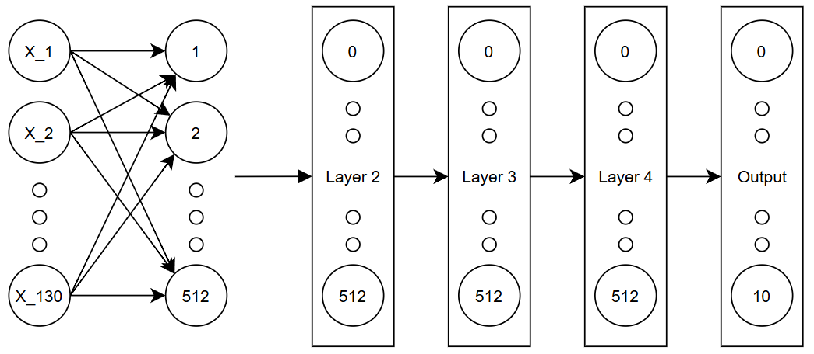
For the training loop we tracked the best test loss over the training process and stopped the training the moment when no better test loss was achieved. We decided to use the test loss for the model performance evaluation because by tracking the performance of the model based on the already seen data (training data) we would have the risk of taking a overfitted model as the best one. After the training loop ended, we loaded the parameters that were saved in the best run of the model and then save this model in an external file. This allows us to use this pre-trained model to make predictions on our dataset without the need to train again. 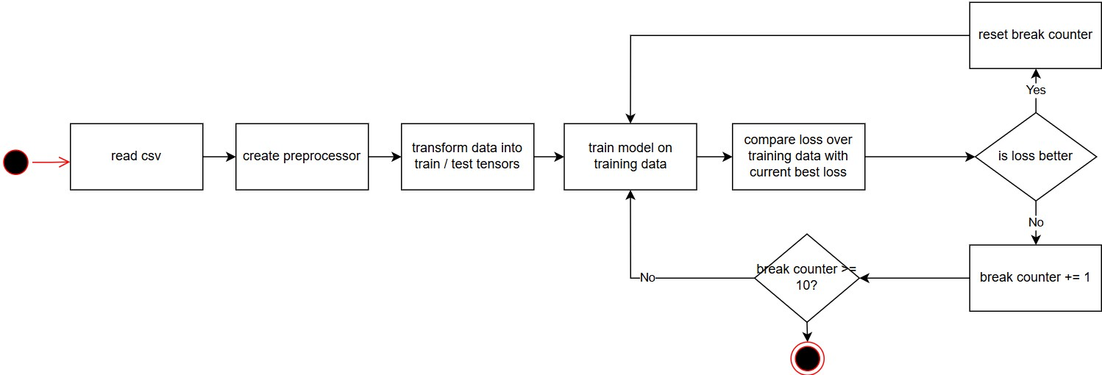
To check the real accuracy of our model and to see how the model performs on the different length-of-stay groups, we split our data into 11 different datasets where each consists only of rows that have the length of stay x. Then we made predictions on each class and tracked the prediction of the model (you can see the result below). For example, the model predicts stay 0-10 in 21.8% of all cases as stay 0-10 (which is correct) but also predicts the stay group 0-10 in 43.1% of all cases as 11-20. Some classes, such as 41-50, are predicted with 0% accuracy because there were only a few rows of training data available for that class. During training, the model optimized for overall loss across all samples, so when the class is underrepresented, the model learns that it's statistically safer to predict a majority class instead of risking a wrong guess on a rare one. For example, since 21-30 has by far the most training examples, the model learns a high prior probability for it and tends to default to predicting 21-30 even for inputs that actually belong to a minority class like 41-50. As a result, the model essentially "gives up" on the rare classes in favor of minimizing loss on the classes it sees most often.
